Screenshots :

Step 1 : creating the spring the Spring boot project 🡺 Logs are generated in this project are send via Logstash to elastic search and finally view the logs in the Kibana

To run the docker console ELK

1. Install the docker in system
2. Open the command prompt in the current location folder where you have all the yml files i.e
3. Docker-compose.yml file
4. Logstash.yml file
5. Logstash.config file
6. Then run the command 🡺 “docker-compose up”

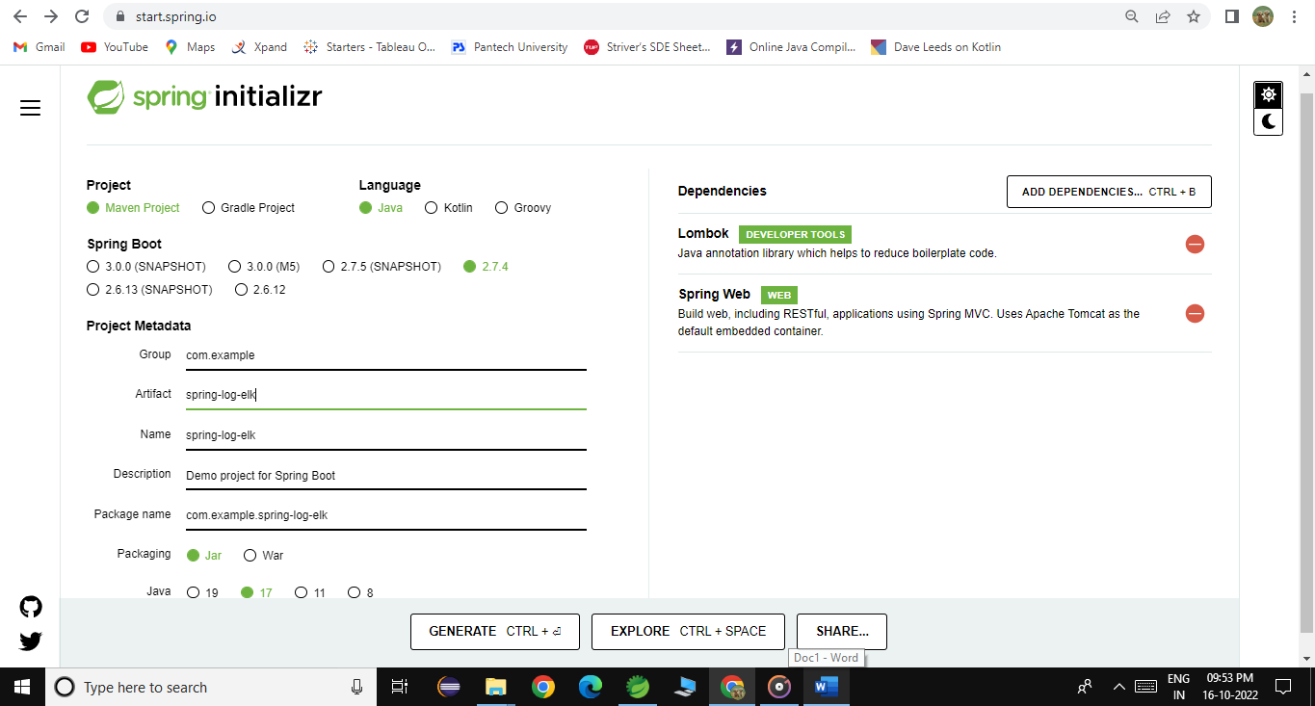

Import the spring boot project created in the visual studio code

Then create one folder and create the docker-compose.yml file where we give all the configuration for the elastic search, kibana , and the logstash

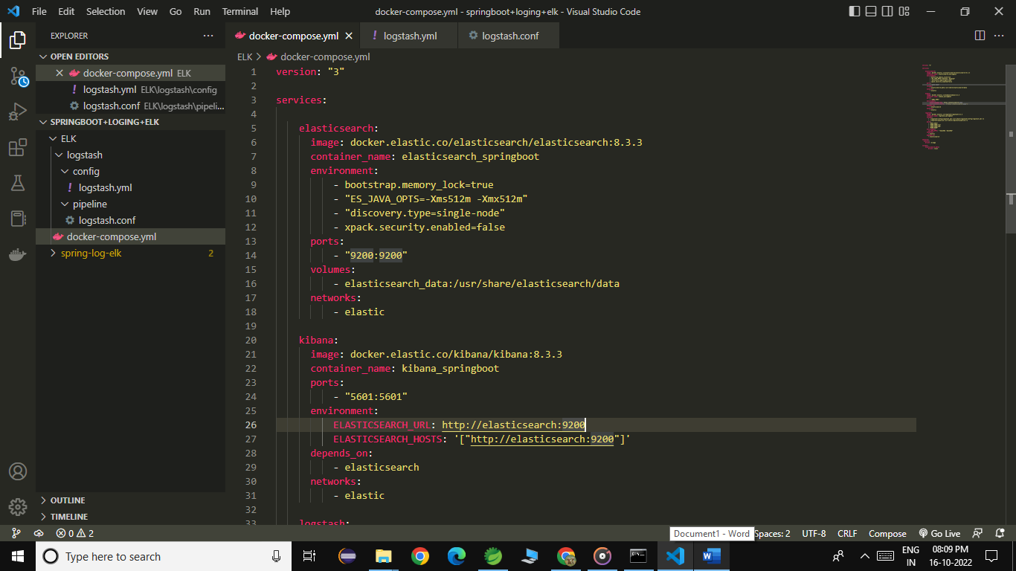

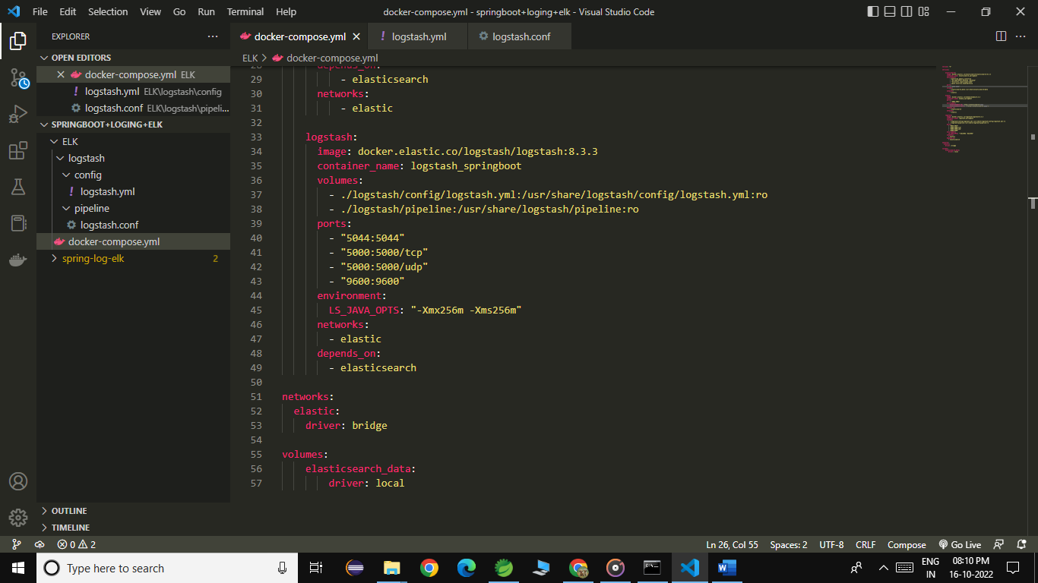

Then create the logstash.yml file

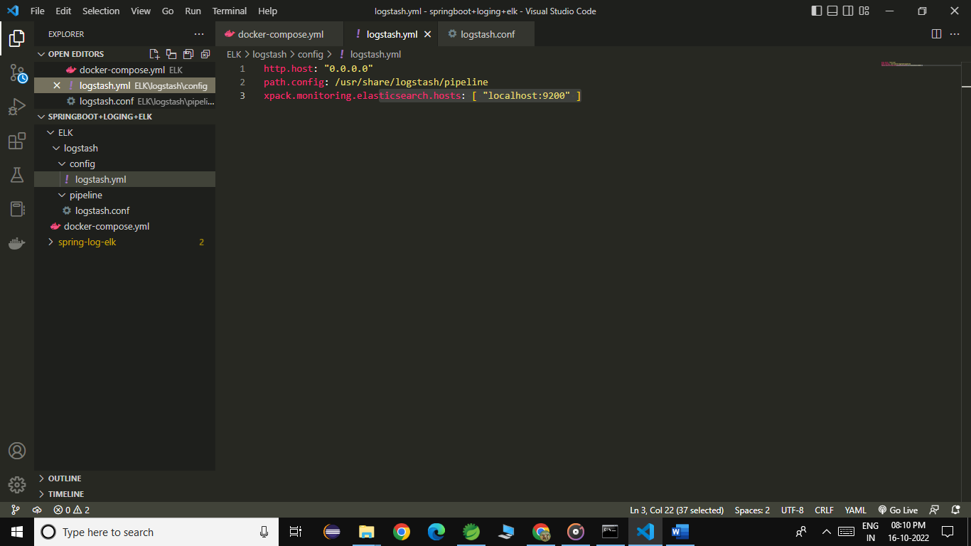

Here is the configuration, where we give the hosts and index

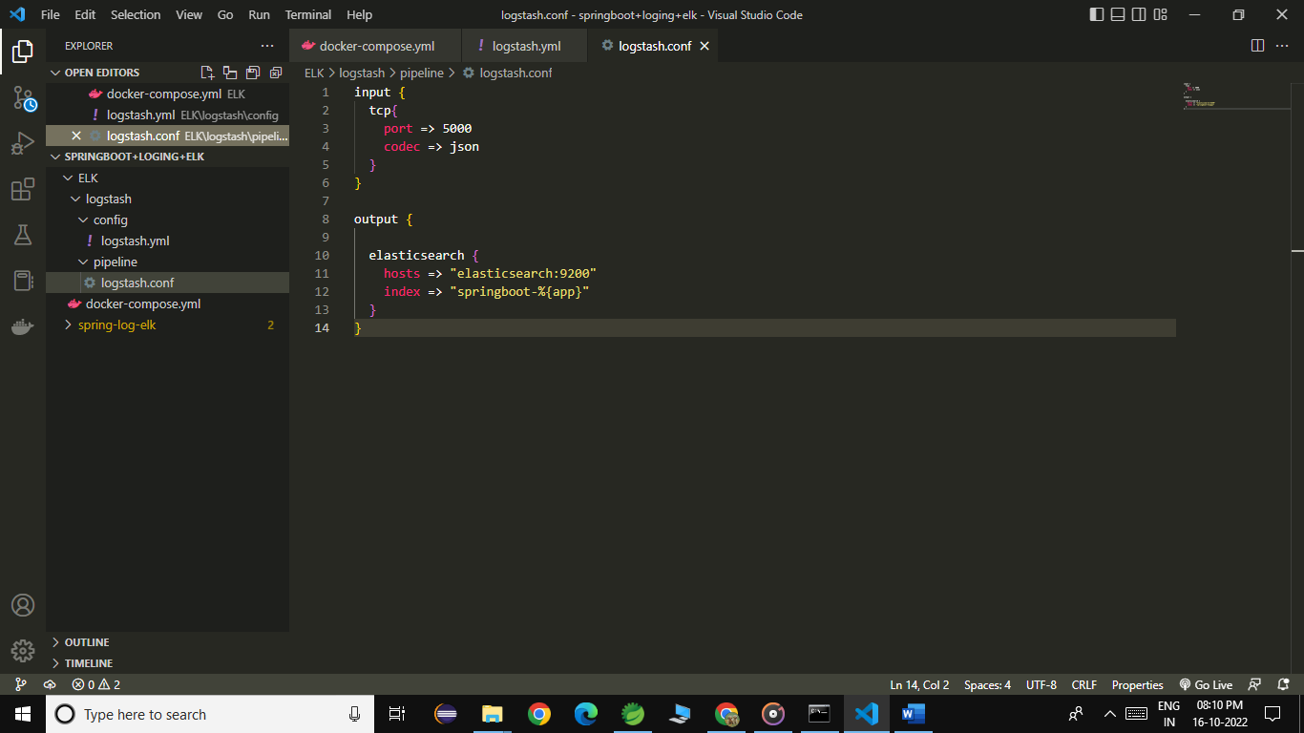

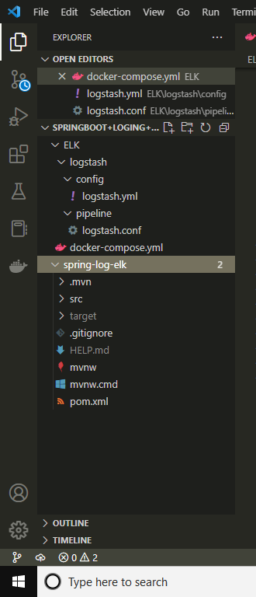

Command “docker-compose up”

Then it will check the form bridge between the logstash , elastic search and the kibana

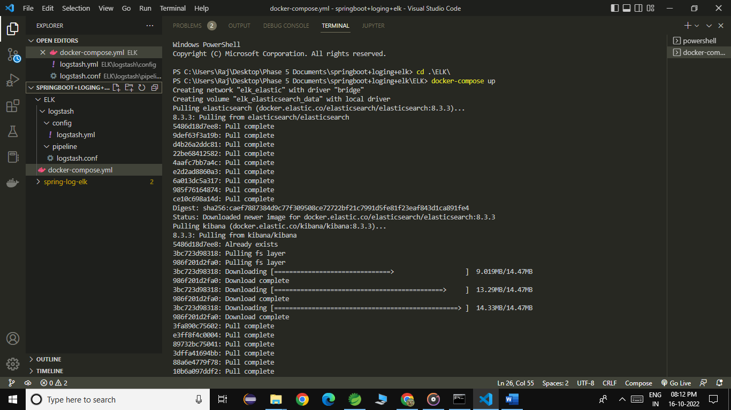

Here is the image for pull the images form the docker hub

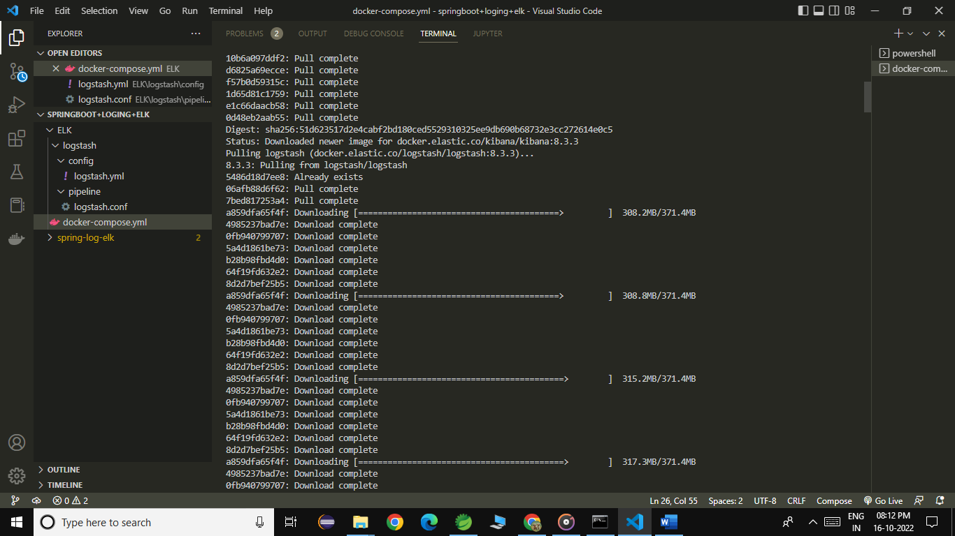

Then it will shows that the logs

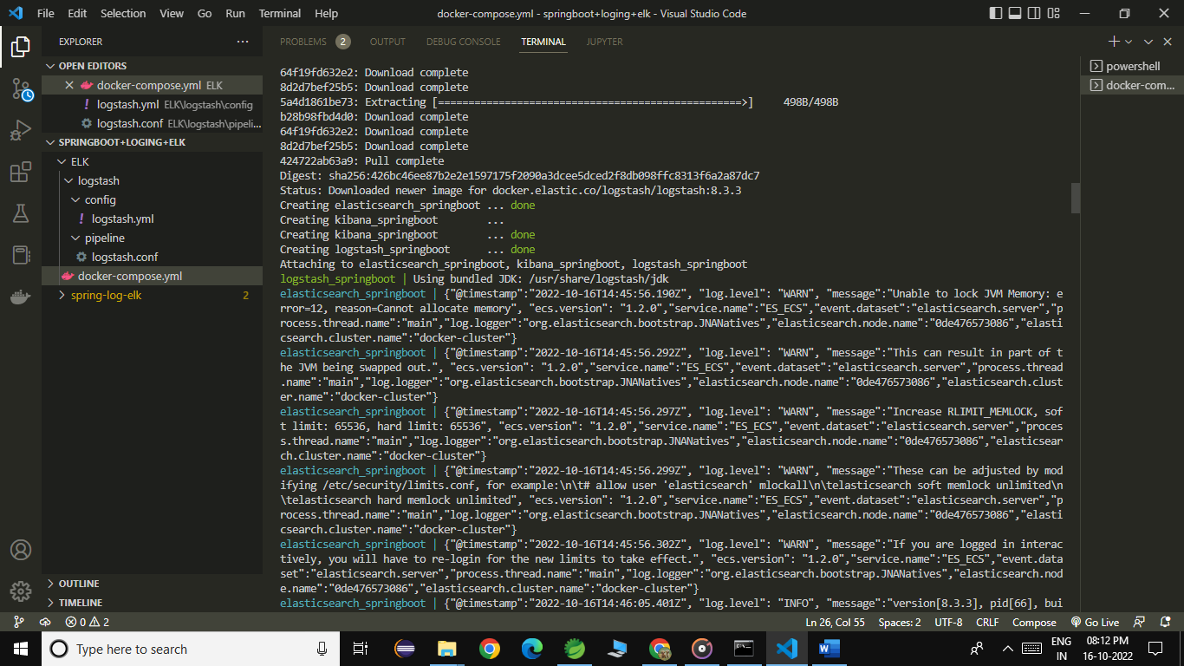

Logs generated:

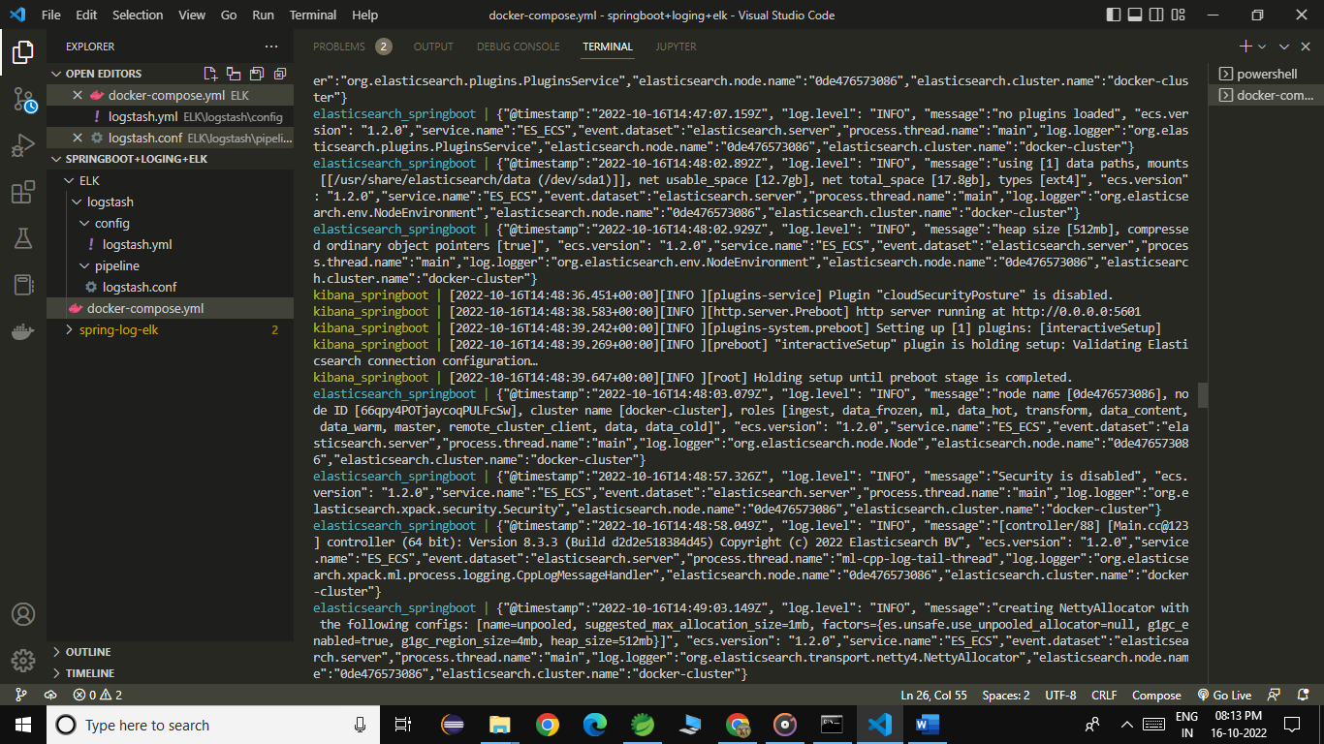

Logs generated:

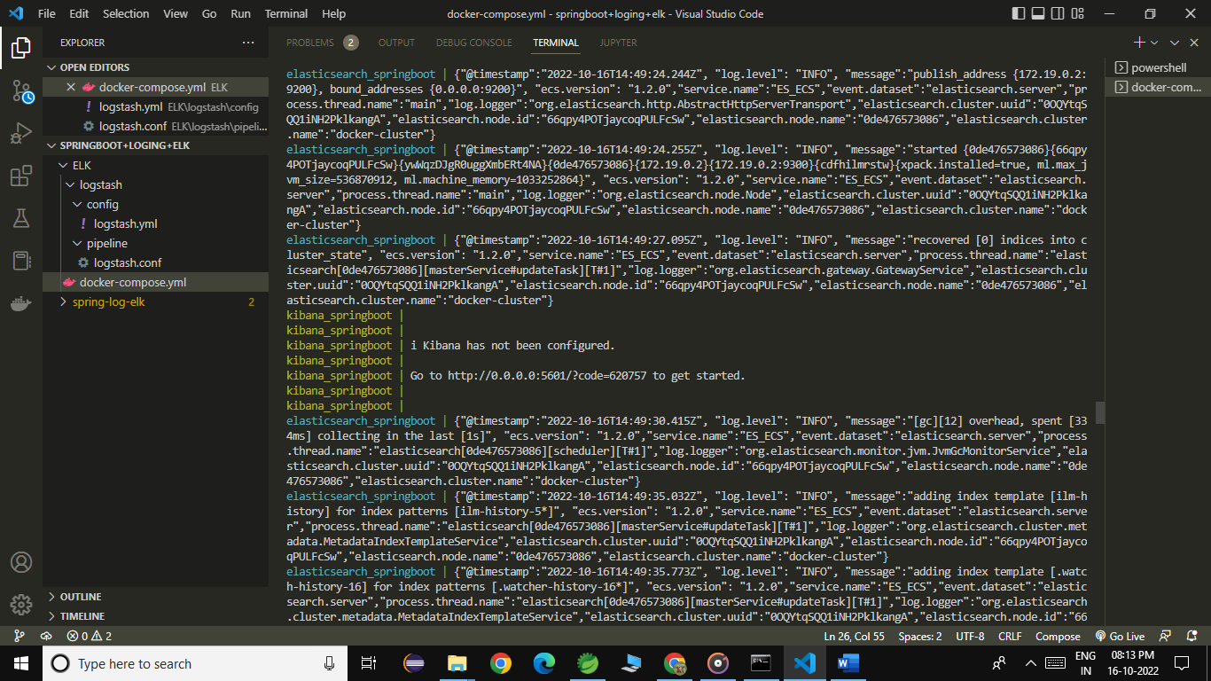

Logs generated:

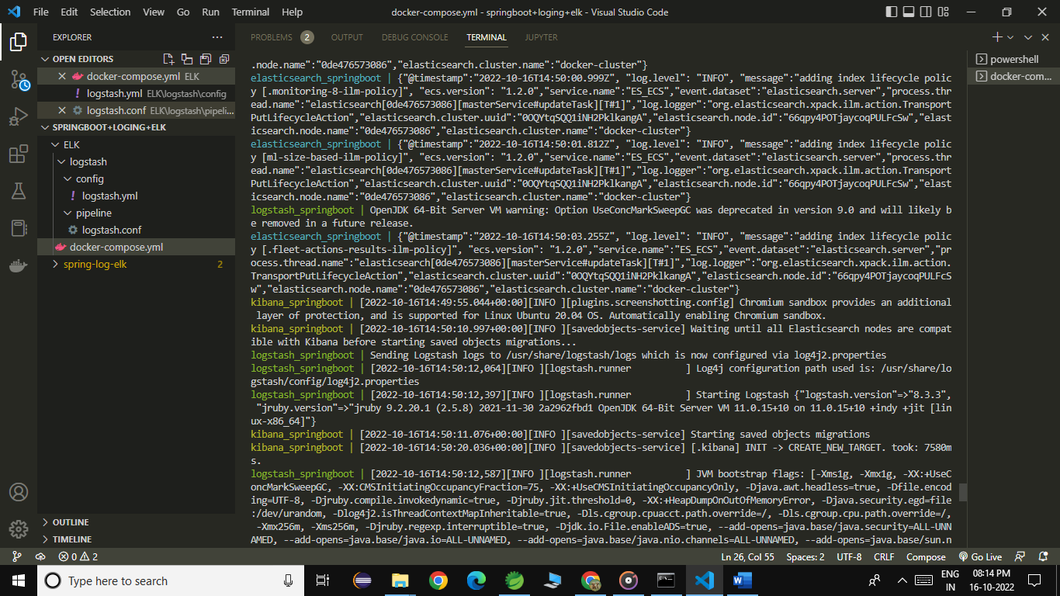

Logs generated:

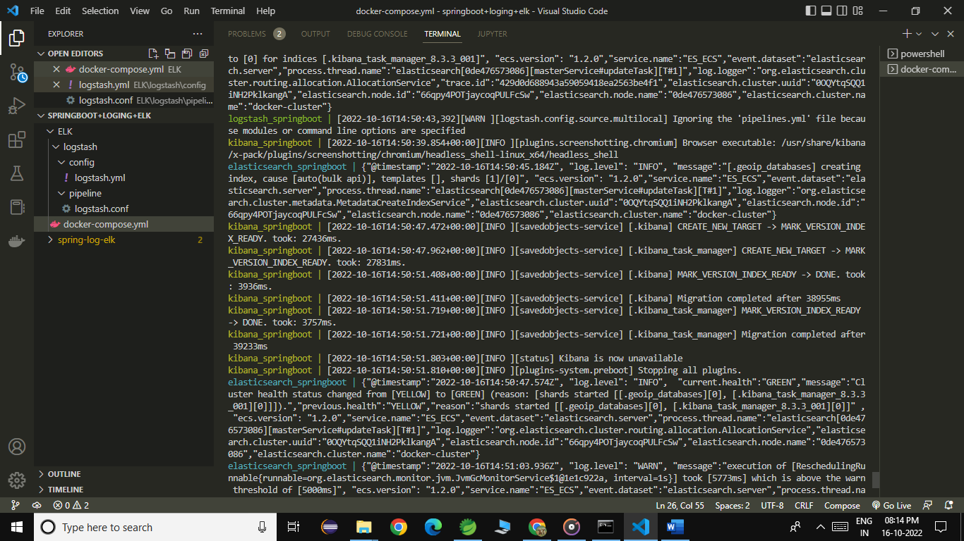

Logs generated:

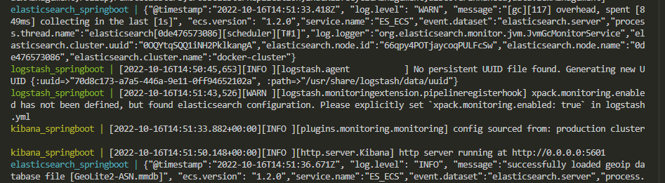



Docker images

1. Pull the elasticsearch 🡺 (Version – 8.3.3)
2. Pull the kibana 🡺 (Version – 8.3.3)
3. Pull the logstash 🡺 (Version – 8.3.3)

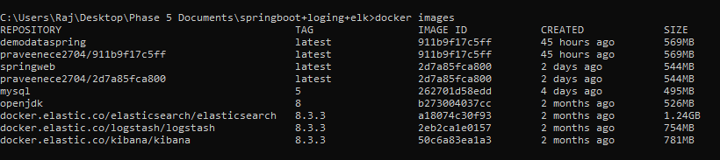

Then move on to the STS tool where we give the dependency for logstash

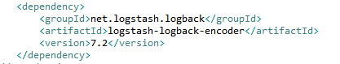

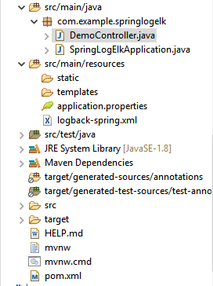

Here we created one controller for generating the logs

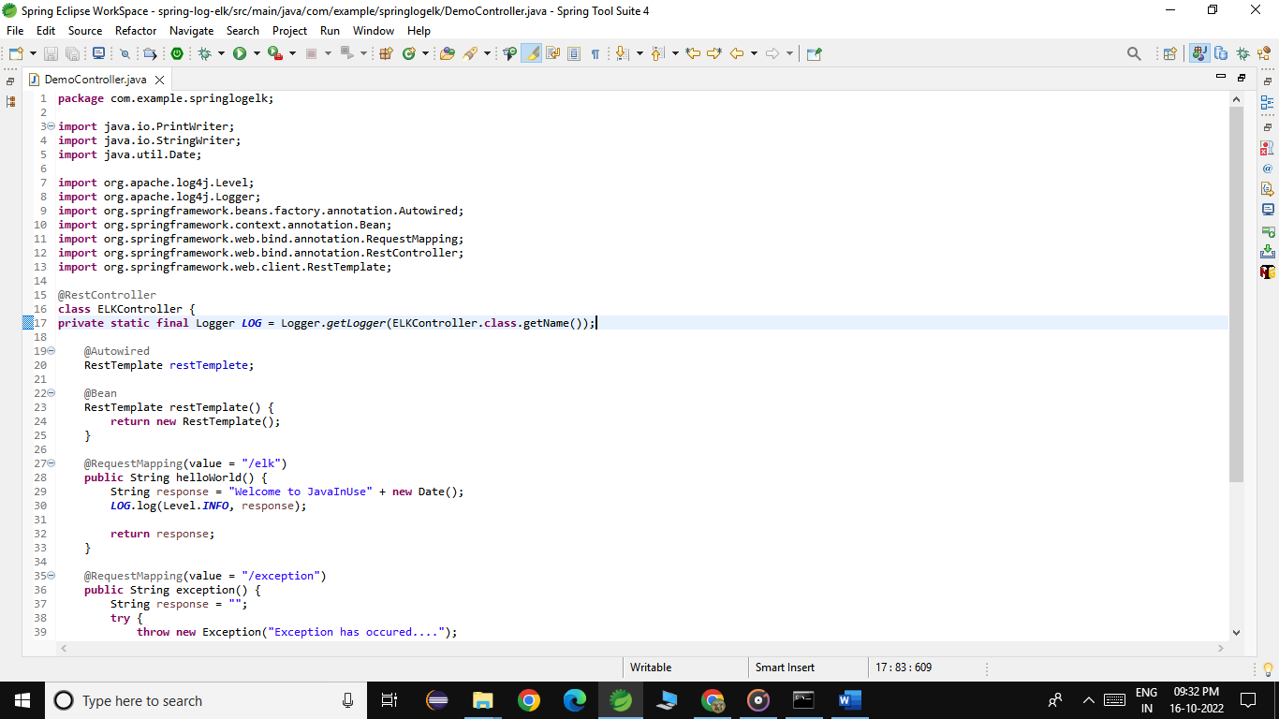

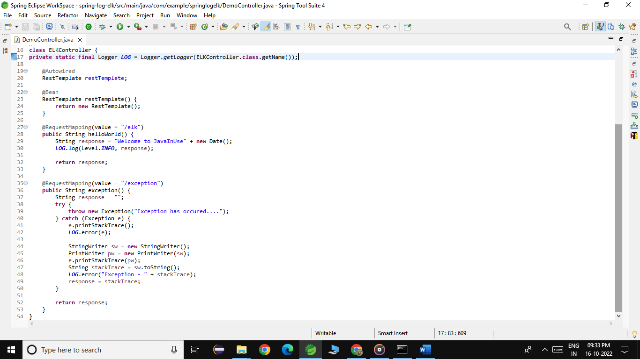

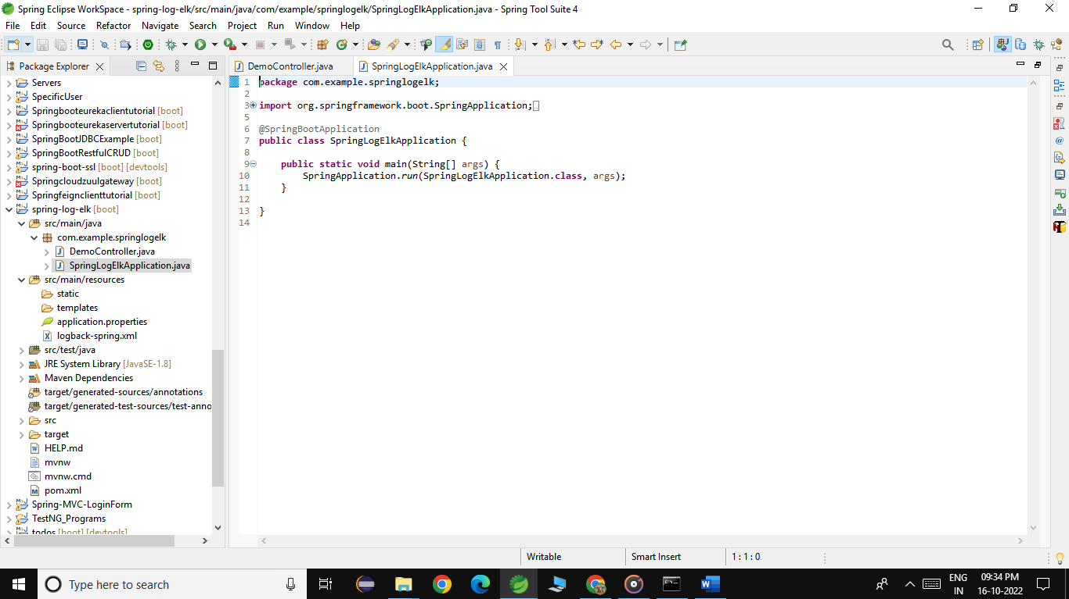

Then created one logback-spring.xml file

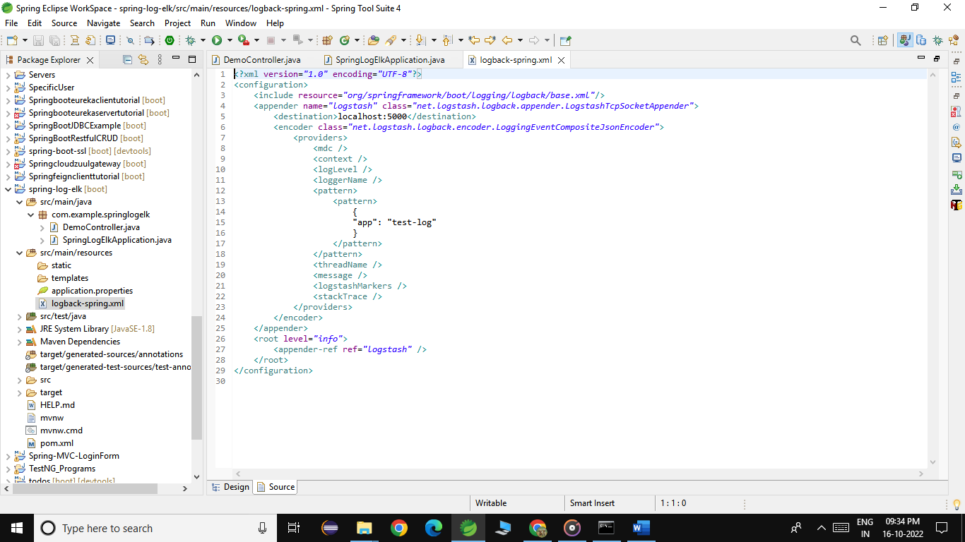

Pom.xml file

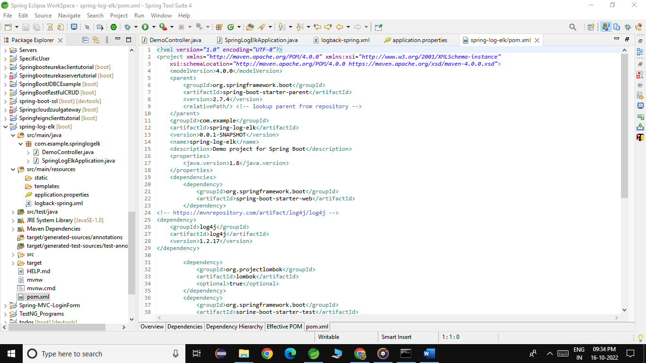

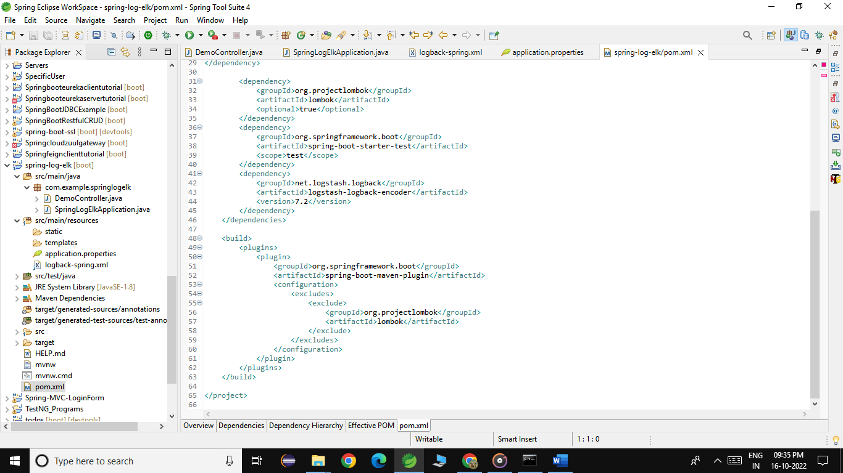

Kibana logs are generated in the spring boot application is displayed in the kibana :

